**NAGARJUNA COLLEGE OF INFORMATION TECHNOLOGY**

**TRIBHUVAN UNIVERSITY**

**INSTUITE OF SCIENCE AND TECHNOLOGY**

A Project Proposal on

**Education Explorer Recommendation System**

Submitted To:

**Department of Computer Science and Information Technology**

**Nagarjuna College of Information Technology**

**In partial fulfillment of the requirements for the**

**Degree of BSc.in Computer Science and Information Technology**

**By**

Biswas Shrestha (3270/070)

Smaran Maharjan (3283/070)

Samit Shakya (3284/070)

Sanjay Pokhrel (3285/070)

May 3, 2017

**Table of Contents**

CHAPTER-1 INTRODUCTION 2

1.1 Introduction to Education Explorer 2

1.2 Problem statement 3

1.3 Objectives of the System 3

1.4 Scope of the System 3

CHAPTER-2 LITERATURE REVIEW 4

2.1 Study of Existing system 4

2.2.1 Functional Requirements 5

2.2.2 Non- functional requirements 7

2.2 Feasibility Study 8

2.2.1 Technical Aspect 8

2.2.2 Operational Aspect 8

2.2.3 Economical Aspect 8

2.3 Tools 9

2.3.1 Analysis and Design 9

2.3.2 Implementation Tools 9

CHAPTER-3 SYSTEM DESIGN 11

3.1 Flow Chart 11

3.2 GANTT Chart 12

CHAPTER-4 EXPECTED OUTPUT 13

REFERENCES 14

# **CHAPTER-1 INTRODUCTION**

## 1.1 Introduction to Education Explorer

Education Explorer is a recommendation engine that uses recommendation algorithm and data mining techniques to finds the college that’s right for you. It is an android that guides the client on choosing the right college and course according to client’s requirements and field. This app will let you find the better college in any particular filtered by city having ranks based on their placements, college facilities and quality of education.

This app is made for students as well as parents to find and choose from hundreds of colleges and universities according to their major subjects, programs, scholarships and choose the best among them. It gives detail information of scholarships/bursaries/fellowships according name, majors and institutions fitting the profile to fund your educations. This app finds information about financial aid statistics such as average amount, percent of student received, total amount received for university of your choice. It customizes and narrow down your search with location, courses and majors. Also, a list of top Kathmandu valley’s colleges and their eligibility criteria and admission details are also available in this app. Not only this, this app will also help you to shortlist the colleges as per your choice and also contact details of the relevant college administration staff will also get available to you through Education Explorer app. It contains university details and redirects directly to the university websites.

You can also get notification about upcoming educational, technical events happening around Kathmandu valley on your phone. This app mainly focuses the colleges in Kathmandu Valley and targeted for the students who are studying in Kathmandu Valley or are planning to come for studying in Kathmandu valley. “Education Explorer” is one-stop-shop for “Inspiring students to make an informed choice”

## 1.2 Problem Statement

Kathmandu valley is a big city. It is difficult to find and visit each and every college and get their details is very difficult. As a result, student can’t get enough information or proper enrollment according to requirement. On the other hand, for a student it is waste of time for searching college instead of studying.

Student are even found to be in dilemma to get best course for their future or the best institute for them to enroll. An expert advice can be a key for better understanding of concepts of the faculty or course description.

## 1.3 Objectives of the System

The objectives of education explorer recommendations are given s follows:

* To provide recommending according to the selected course by the category.
* To provide detail information about course including trending course.
* To find information about financial aid statistics such as average amount, percent of student received, total amount received for university of your choice.
* To save time and effort, you can compare schools of your choice and find best that fits your criteria.

## 1.4 Scope of the System

The era of mobile technology opens the windows to the android app. It is the time to change from conventional websites to apps, which has become the part of our daily routines. “Education Explorer” the android application which gives the list colleges in Kathmandu and their eligibility criteria and admission details according to your search. It gives you more comfort and a better user interface. This application is currently prepared for the android OS.

# **CHAPTER-2 LITERATURE REVIEW**

## 2.1 Study of Existing system

We recently had studied about the different application software which works as like this application. As per my research, we had studied about the application named “Education Finder College Search” which is made mainly focusing the students of United States, france and other European countries which find and choose from more than 25 thousand colleges.

* Scholarships/bursaries/fellowships
* Financial aid & stats
* Check out reviews & find alumni’s.
* Stay tuned & get involved in schools with get social
* Salary dataset
* Compare schools
* Forum
* Track university application & get notifications
* Visa information
* Checklist
* News feeds

ADDITIONAL INFORMATION

* Updated: - August 31, 2016
* Installs: - 10,000 - 50,000
* Current Version: - 2.2
* Requires Android: - 4.0 and up
* Content Rating: - Rated for 3+
* Offered By: -Education Finder LLC[7]

**2.2 Requirement Identification**

### **2.2.1 Functional Requirements**

* Input:
* System must be able to take inputs from the users
* Searching:
* System will be able to search the information that user ask/need.
* Feedback:
* The user will be able to leave feedback, which is comprised of a text message and a rating.
* Administrative System:
* Information management: The administrator will be able to add, update & delete question, answer & keywords.
* Log management: The administrator will be able to view and delete logs
* Feedback management:
* The administrator will be able to view and delete feedbacks. Output
* System must be able to give meaningful output to the users as per the given input

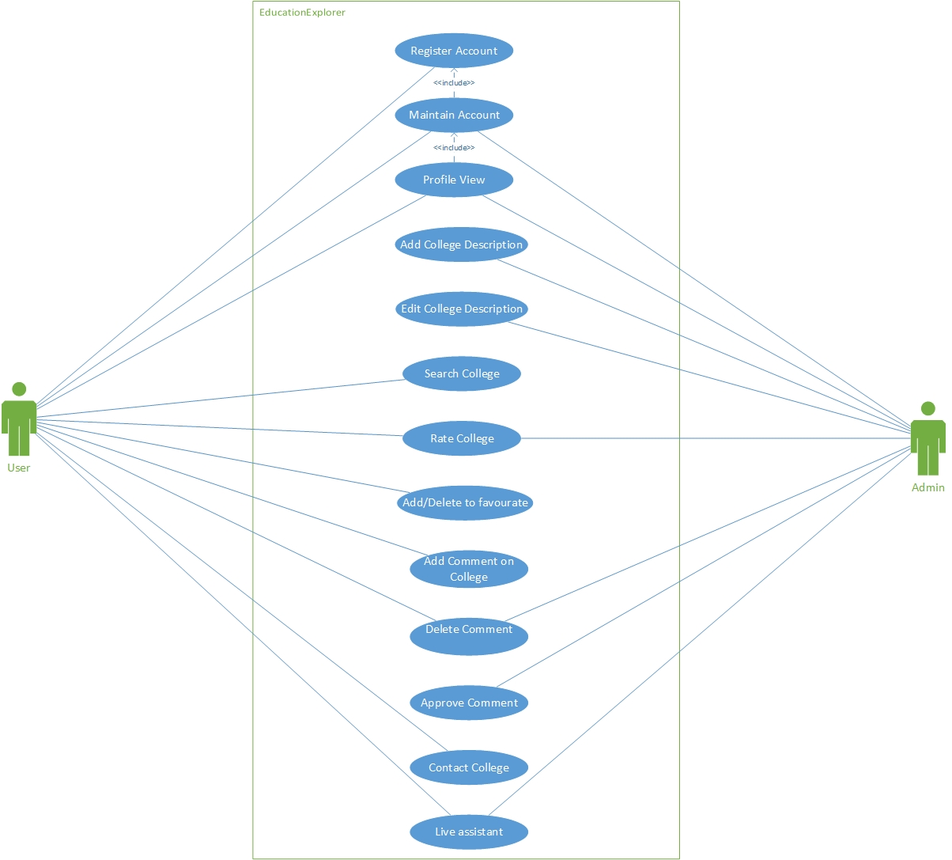

Fig: Use Case Diagram of Education Explorer

### **2.2.2 Non- functional requirements**

* User Interface
* The system shall maintain an easy to use interface across all functionality and for all users
* The client’s user interface should be compatible with all commonly used devices, such as HTC.
* Scalability:
* The system will be able to scale based on the number of users using the system.
* Security:
* The administrative will be protected from unauthorized access.
* The database will be protected from attacks and unauthorized access.
* All passwords will be stored as a secure hash of the administrator password.
* Portability:
* The system will run on a variety of operating system that support android.
* Maintainability:
* The system will be easy to maintain.
* There will be clear separation of back end and front end.
* There will be a clear separation between the data access objects that map the database and the business logic code.
* Exception handling:
* Exceptions will be reported effectively to user if they occur.
* Ethics:
* The system will not misuse any information about its users.

## 2.2 Feasibility Study

This project carries goals that could be realistically accomplished. We have a clear goal of this. Since, android application is not going to be highly complex, it will not need a lot of processing power, as it runs in a simple in any android versions.

### **2.2.1 Technical Aspect**

All the technology needed for the system exists. Python Language is platform independent and highly powerful language. Python has multiple libraries that reduces effort and facilitate programmer. Android is used in front end which is very flexible. From the above observations, we can say that the system would be technically feasible.

### **2.2.2 Operational Aspect**

The proposed system would solve the educational problems and take advantage of the opportunities. The new systems would fit into the current day-to-day operations of the client. The system would save the time and effort of the clients. Thus, the system would be operationally feasible.

### **2.2.3 Economical Aspect**

The software used are open source software which can be easily available for free of cost. We do not need complex and expensive hardware for the application.

## 2.3 Tools

### **2.3.1 Analysis and Design**

Use case diagram: Use case diagram is used to know about the functional requirements. Use case diagram is designed using Microsoft Visio.

Gantt chart: Gantt chart shows the timing of project. It is used for scheduling the project process. It is designed using Microsoft Project.

### **2.3.2 Implementation Tools**

**Front End**

* Android Studio

Android Studi**o** is the officialintegrated development environment (IDE) for the Android platform. [6]

It will be used to make the front end of the system.

**Back End**

* Database Management System:

Database will be used to store the information of the educational intuitions, users profile and their relativity. We would be using MySQL to maintain database.

* Data Mining Algorithm:

Data mining would be used in discovering patterns in large data sets involving methods at the intersection of artificial intelligence, machine learning, statistics, and database systems. We will be using K-Means clustering algorithm.

**Algorithmic steps for k-means clustering**

Let X = {x1,x2,x3,……..,xn} be the set of data points and V = {v1,v2,…….,vc} be the set of centers.

1. Randomly select *‘c’* cluster centers.
2. Calculate the distance between each data point and cluster centers.
3. Assign the data point to the cluster center whose distance from the cluster center is minimum of all the cluster centers.
4. Recalculate the new cluster center using:

where,*‘ci’* represents the number of data points in *ith* cluster.

1. Recalculate the distance between each data point and new obtained cluster centers.
2. If no data point was reassigned then stop, otherwise repeat from step 3).

* Recommendation Algorithm:

For this system, we will be using feature based recommendation algorithm which recommends according to the feature of the objects. We will be using feature based recommendation algorithms.

**Algorithms Criteria**

1. Quality of Predictions
2. Speed/Scalability
3. Easily Updated
4. Cold start ability
5. Sparse data handling

* Python:

We will use python for backend and server side programming of the system for data mining and profile generation purpose.

# **CHAPTER-3 SYSTEM DESIGN**

## C:\Users\Biswas\AppData\Local\Microsoft\Windows\INetCache\Content.Word\proposKamana.jpg3.1 Flow Chart

Fig: System Flow Chart of Education Explorer

## 3.2 GANTT Chart

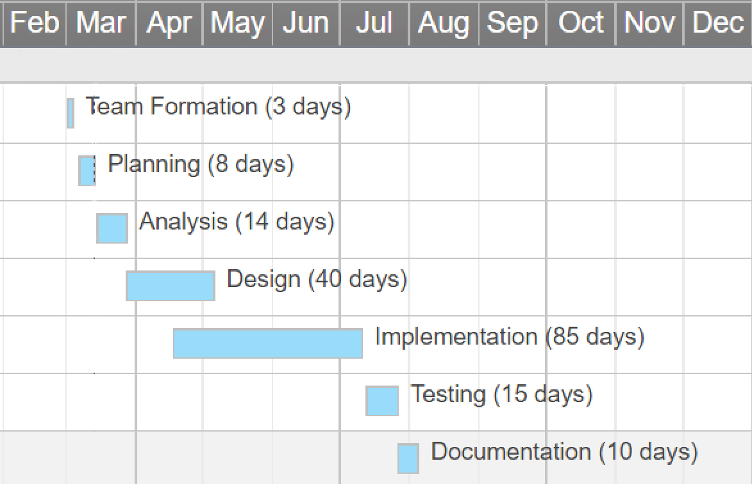

Fig: Project scheduling GANTT chart

# **CHAPTER-4 EXPECTED OUTPUT**

This system is expected to be an effective recommendation system that selects the best educational institution for the clients. This android application will be efficient as most of the students and parents these days are having smart phones running on android OS and it will be very much convenient for them to find an appropriate college at any time, any place just by entering the location, courses and major they like. The system’s is GUI based environment is expected to save the client’s time, cost and effort with maximum efficiency and reliability.

# REFERENCES

1. Baker, H. Kent, and Powell, Gary E., Understanding Financial Management: A Practical Guide.  Blackwell Publishing.
2. Chen, M.T.,  (1996), “ Simplified project economic evaluation.”  Transactions of AACE International. ABI/INFORM Global.
3. Cohan, P.S., (2005), “CFOs to Tech: ‘I’ll Spend For The Right Technology’.” Financial Executive Apr 2005. ABI/INFORM Global.
4. Demirhan, D.,   Jacob, V.S., and Raghunathan, S., (2006), “Information Technology Investment Strategies Under Declining Technology Cost.” Journal of Management Information Systems.  Vol. 22 No. 3, Winter 2006. pp. 321 – 350
5. Willbanks., Linda (2007), "Passing out IT Toys." CIO Corner, IT Pro. November/December 2007.
6. https://developer.android.com/index.html
7. https://www.ed-finder.com/
8. https://www.python.org/
9. https://www.w3schools.com/
10. http://www.saedsayad.com/clustering_kmeans.htm